TailorTech Website Content Draft

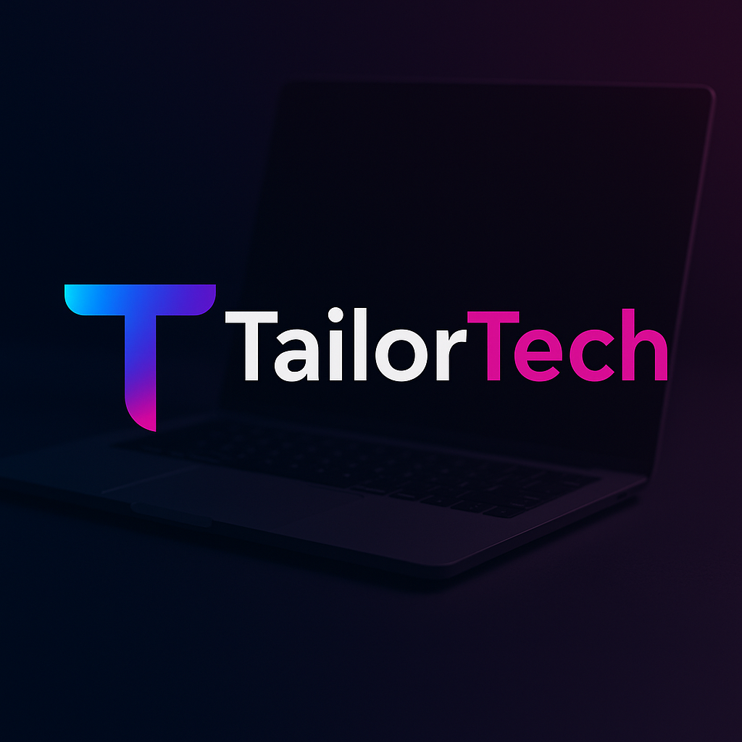


1. Home Page
A. Hero Section
Build Real Tech Skills with
TailorTech
Where Skills Are Tailor-Made.

B. What We Offer
At TailorTech, we offer carefully designed programs focused on building strong fundamentals, practical skills, and real-world project experience in modern software technologies.
• Course cards for main programs
Java Frontend Development
Description
Learn how to build modern and responsive user interfaces using core frontend technologies and best development practices.
Duration: 75 hours
Mode: Live Online
Focus: UI development, responsive design, and frontend fundamentals
Button: View Details

Java Backend Development
Description
Understand how backend systems power modern applications, including server-side logic, APIs, and database integration.
Duration: 90 hours
Mode: Live Online
Focus: Backend architecture, API development, and database management
Button: View Details

Java Full Stack Development
Description
A complete program covering both frontend and backend development, helping learners build full web applications from scratch with real time projects and mock interviews.
Duration: 175 hours
Mode: Live Online
Focus: End-to-end application development and full stack architecture
Button: View Details

Data Engineering
Description
Learn how modern data platforms and pipelines are built to process and manage large datasets for real-world applications.
Duration: 120 hours
Mode: Live Online
Focus: Data pipelines, data processing, and industry tools used in data engineering
Button: View Details

Java Full Stack Development (Recorded Program)
Description
A self-paced recorded program designed for learners who prefer flexible learning. Build a strong understanding of both frontend and backend development through structured lectures and practical exercises.
Duration: Self-Paced
Mode: Recorded
Focus: Full stack fundamentals, application development concepts, and independent learning
Button: View Details

Mock Interviews
Description
Prepare for real technical interviews through one-on-one mock interview sessions with detailed feedback and guidance.
Duration: 1 hour per session
Mode: Online
Focus: Technical interview practice, problem-solving, and confidence building
Button: Book a Slot

C. Why TailorTech
Points such as:
Practical Learning Approach
Focus on real-world skills through hands-on projects and practical assignments.
Small Live Batches
Interactive learning with personalized attention and mentorship.
Industry-Focused Training
Programs designed around tools and practices used in modern software teams.
Tailor-Made Skill Development
Learning paths designed to help each student grow at their own pace.
Career-Oriented Learning
Guidance and preparation focused on building confidence for real tech careers.

D. Student Feedback / Testimonials
Display student feedback.

E. Upcoming Batches
Start your learning journey with TailorTech. Explore the upcoming live programs and secure your seat in the next batch.

Data Engineering
Next Batch Starts: 10th April
Duration: 120 hours
Mode: Live Online
Seats Available: 17
Button: Apply Now

Java Full Stack Development
Next Batch Starts: 1st May 2026
Duration: 175 hours
Mode: Live Online
Seats Available: 20
Button: Apply Now

F. Final CTA Section
Start Building Skills That Are Truly Tailor-Made.
Subtext below it:
Join TailorTech and learn through practical projects, small live batches, and focused mentorship designed to help you grow in the software industry.
A large section with Apply Now button.
When clicked → redirect to WhatsApp.

2. Our Programs Page
This page will list all programs.

Java Full Stack Developer Program
175 Hours | Live Online
The Java Full Stack Developer Program at TailorTech is designed to help learners become job-ready software developers with strong fundamentals and real-world project experience.
This program takes learners from core programming concepts to building complete enterprise-level applications, following an industry-focused learning path aligned with modern software development practices.
Through structured live sessions, hands-on assignments, and real-world projects, participants gain practical exposure to the tools and technologies used in modern full stack development.

What the Program Covers
Frontend Development
HTML, CSS, JavaScript, Bootstrap, and React for building modern and responsive user interfaces.
Backend Development
Java, Spring Boot, and Microservices architecture for building scalable backend systems and APIs.
Database Technologies
SQL, JPA, and Hibernate for efficient data storage, management, and integration with applications.
DevOps & Cloud
Introduction to Docker, Kubernetes, CI/CD pipelines, and AWS to understand modern deployment practices.
Real-World Projects
Hands-on experience through projects such as an E-commerce platform, Food Delivery application, and Issue Tracking system.

What You Get
• Live instructor-led sessions
• Real-world project experience
• Code reviews and technical guidance
• Mock interviews and interview preparation
• Industry-aligned learning roadmap

Program Details
Duration: 175 Hours
Mode: Live Online
Batch Size: Small batches for focused learning

Course Fee
Regular Fee: $350 USD
Early Bird Fee: $300 USD
Limited seats available for each batch.

Apply Now
Start your journey toward becoming a Java Full Stack Developer with TailorTech.
Apply Now

_________________

Frontend Development – Module 1
75+ Hours | Live Online
The Frontend Development program at TailorTech is designed to help learners build a strong foundation in modern web development. This module focuses on creating responsive, interactive web interfaces while understanding the core concepts that power modern frontend applications.
Through structured live sessions and hands-on project work, learners gain practical experience with essential frontend technologies and development practices.

What the Program Covers
HTML & CSS
Build structured and responsive web pages using modern layout techniques.
JavaScript & ES6 Fundamentals
Understand the core concepts of JavaScript and modern ES6 features used in real-world development.
React Framework
Learn to build dynamic and component-based user interfaces using React.
Real-World Frontend Projects
Apply your learning by building practical projects that simulate real development scenarios.

What You Get
• Live instructor-led sessions
• Hands-on project-based learning
• Practical exposure to frontend technologies
• A strong foundation for starting a career in frontend development

Program Details
Duration: 75+ Hours
Mode: Live Online

Course Fee
Program Fee: $150

Apply Now
Start your journey into frontend development with TailorTech.
Apply Now

Backend Development Program
90+ Hours | Live Online
The Backend Development program at TailorTech is designed to help learners build strong server-side development skills and prepare for backend-focused software engineering roles.
This program focuses on the core technologies and concepts used to build scalable backend systems, APIs, and data-driven applications. Through structured live sessions and hands-on projects, learners gain practical experience in building and managing backend services used in real-world applications.

What the Program Covers
Core Java & Object-Oriented Programming
Build a strong foundation in Java programming and object-oriented design principles.
Databases & Data Management
Learn SQL, database design, JPA, and Hibernate for efficient data storage and application integration.
Spring Boot & REST APIs
Develop scalable backend services and RESTful APIs using Spring Boot.
Security & Microservices Fundamentals
Understand Spring Security concepts and the basics of microservices architecture.
Backend Architecture & Best Practices
Learn how backend systems are structured and how to write maintainable and scalable backend code.
Real-World Backend Projects
Gain practical experience through backend projects and API integrations.

What You Get
• Live instructor-led sessions
• Real-world backend projects and code reviews
• Mock technical interviews and interview preparation
• Structured, job-oriented learning roadmap

Program Details
Duration: 90+ Hours
Mode: Live Online

Course Fee
Program Fee: $200 USD
Limited seats available for each batch.

Apply Now
Build strong backend development skills with TailorTech and take the next step in your software development journey.
Apply Now
_______________

Data Engineering Master Program
120 Hours | Live Online
The Data Engineering program at TailorTech is designed to help learners build strong foundations and practical skills required to work as a Data Engineer.
This program covers the core concepts of data engineering, modern data processing tools, and cloud-based data systems through structured learning and hands-on projects.

What the Program Covers
Data Engineering Foundations
Build a strong base in core data engineering concepts.
Topics include:
• SQL for data engineering
• Python for data processing
• Linux basics and shell scripting
• Git and version control
• Data warehouse fundamentals
• Data modeling (Fact & Dimension tables, Star vs Snowflake schema)
• ETL vs ELT and incremental data pipelines
• Medallion architecture and pipeline design basics
• Introduction to NoSQL systems

Big Data Processing & Orchestration
Learn how large-scale data systems process and manage data pipelines.
Topics include:
• Apache Spark and Spark SQL
• DataFrames, transformations, joins, and aggregations
• Performance tuning fundamentals
• Databricks and Delta Lake basics
• Apache Airflow for workflow orchestration
• Pipeline scheduling, dependencies, and monitoring
• Kafka fundamentals and event-driven architecture
• Batch vs streaming pipelines

Cloud Data Engineering & Projects
Understand modern cloud-based data systems and real-world implementation.
Topics include:
• dbt fundamentals and data transformation workflows
• Data quality checks and monitoring
• Cloud concepts for data engineering (AWS / Azure overview)
• Data lake and data warehouse architecture
• Batch vs streaming system design
• End-to-end data engineering capstone project
• SQL, Python, and Spark interview preparation

What You Get
• Live instructor-led sessions
• Hands-on data engineering projects
• Exposure to modern data engineering tools
• Structured learning roadmap
• Interview preparation and guidance

Program Details
Duration: 120 Hours
Mode: Live Online
Batch Size: Small batches for focused learning

Apply Now
Start building practical data engineering skills with TailorTech.
Apply Now

Java Full Stack Development (Recorded Program)
Self-Paced | Recorded Program
The Java Full Stack Development Recorded Program at TailorTech is designed for learners who prefer flexible, self-paced learning while building strong full stack development skills.
This program covers both frontend and backend development, helping learners understand how modern web applications are built from end to end. Through structured recorded sessions and practical exercises, participants can learn at their own pace while building a solid foundation in full stack development.

What the Program Covers
Frontend Development
Learn to build responsive and interactive web interfaces.
Topics include:
• HTML and CSS fundamentals
• JavaScript and modern ES6 concepts
• Bootstrap for responsive layouts
• React for dynamic frontend applications

Backend Development
Understand how server-side systems power modern applications.
Topics include:
• Core Java and object-oriented programming
• Spring Boot framework
• REST API development
• Backend architecture fundamentals

Database & Application Integration
Learn how applications manage and interact with data.
Topics include:
• SQL fundamentals
• Database design basics
• JPA and Hibernate concepts

Full Stack Application Development
Understand how frontend, backend, and databases work together to build complete applications.
Learners will gain a practical understanding of full stack architecture and development workflows.

What You Get
• Structured recorded sessions
• Self-paced learning flexibility
• Practical full stack development concepts
• Strong foundation for modern web development

Program Details
Mode: Recorded / Self-Paced
Access: Learn anytime at your own pace

Apply Now
Start learning full stack development at your own pace with TailorTech.
Apply Now

Mock Interviews:
Students should be able to book a slot (or redirect to WhatsApp for booking).

Mock Interview Sessions
1 Hour per Session | Live Online
TailorTech Mock Interview Sessions are designed to help learners prepare confidently for technical interviews. These one-on-one sessions simulate real interview environments and provide valuable feedback to improve problem-solving, technical understanding, and communication.
Each session is conducted by an industry professional who evaluates your approach and provides detailed feedback to help you perform better in real interviews.

What the Session Includes
• One-on-one mock interview with an industry expert
• Real interview-style technical questions
• Evaluation of problem-solving approach
• Feedback on technical concepts and coding style
• Guidance on improving interview performance

Who It Is For
• Students preparing for technical interviews
• Developers looking to improve interview performance
• Professionals preparing for backend, full stack, or data engineering roles

Session Details
Duration: 1 Hour per session
Mode: Live Online (One-on-One)

Book a Session
Prepare with confidence and gain valuable insights before your real interviews.
Book a Slot

3. About Page
About TailorTech
TailorTech is a learning initiative focused on building practical, industry-ready technology skills through thoughtful and structured learning experiences.
The idea behind TailorTech comes from a simple belief — learning technology should not be generic. Every learner has a different background, pace, and career goal. At TailorTech, programs are designed with the philosophy that skills should be built carefully, practically, and in a way that truly prepares someone for real-world software development.
Our programs focus on practical learning, real-world projects, and strong fundamentals rather than just theoretical content. Through live online sessions, personalized guidance, and self-paced learning options, TailorTech aims to create an environment where learners can develop confidence in building real software systems.

Our Philosophy
At TailorTech, we believe that strong careers in technology are built on clear fundamentals, practical understanding, and continuous learning.
Instead of overwhelming learners with excessive information, our programs focus on helping students understand concepts deeply and apply them in real-world scenarios.
This philosophy is reflected in everything we do — from curriculum design to teaching approach.

Our Focus
TailorTech focuses on creating learning experiences that are:
Practical
Programs are designed around real-world tools, projects, and development practices.
Structured
Learners follow a clear roadmap that builds skills step by step.
Focused
Small live batches allow for better interaction and personalized attention.
Career-Oriented
Programs are aligned with real industry expectations and interview preparation.

Our Learning Approach
We emphasize small, focused learning environments where learners can ask questions, receive feedback, and build confidence while working on real projects.
Whether someone is starting their journey in technology or looking to strengthen existing skills, TailorTech provides a learning environment designed to help them grow thoughtfully and build skills that truly matter.

TailorTech
Where Skills Are Tailor-Made.

4. Testimonials Page
At TailorTech, our focus is on helping learners build practical skills and confidence in real-world software development. The experiences and feedback from our learners reflect the learning environment and approach we strive to create.
Here are some thoughts shared by learners who have been part of TailorTech programs.

Student Feedback

(Remove company name from feedbacks, only name and different courses)

Learning Experience
Learners at TailorTech benefit from:
• Practical and project-based learning
• Small batch sizes for better interaction
• Structured learning roadmaps
• Guidance and interview preparation support

Share Your Experience
If you have been part of a TailorTech program, we would love to hear about your learning experience.
Your feedback helps us continue improving and supporting future learners.

TailorTech
Where Skills Are Tailor-Made.

5. Demo Videos Page
Embed YouTube demo lectures / sample classes.

6. Contact Page
Contact Us
Have questions about our programs or want to learn more about TailorTech?
We’re here to help. Feel free to reach out and we’ll get back to you as soon as possible.

Get in Touch
If you would like more information about our programs, upcoming batches, or enrollment process, you can contact us through the details below.
Phone / WhatsApp
+91 73404 45010
Email
tailortech.team@gmail.com
Instagram
Follow us for updates, announcements, and learning content.
@tailortech.in
LinkedIn
Connect with us and stay updated with TailorTech announcements and insights.
TailorTech : https://www.linkedin.com/company/tailortechh

Send Us a Message
You can also reach out by filling out the enquiry form.
Form Fields
• Name
• Email
• Phone Number
• Program Interested In
• Message
Button: Submit

Quick Support
For faster responses regarding program details or enrollment, you can connect with us directly on WhatsApp.
Button: Chat on WhatsApp

TailorTech
Where Skills Are Tailor-Made.

